**Pages 14-26 in *Programming A Comprehensive Introduction***

**Section 1: Key Attributes of Object-Oriented Programming**

Encapsulation- It is a process of wrapping code and data together into a single unit, for example capsule in a medicine i.e. capsule has a several mix medicines.

public- Public is a easiest java access modifiers because a variable or method that is in public means that any class can access it. Its variables are visible to all class.

private- private helps to encapsulate your methods and variables most effectively. Its variables are visible to only those class which they belongs.

access modifier- It specifies which classes can access a given class and its fields, constructors and methods. Access modifiers can be specified separately for a class, its constructors, field and methods.

Class- A class is a blueprint from which individual objects are created.

Object- Objects have states and behaviors. It is an instance of a class. Object is an instance result of a class.

Method- Method is the rules we follow to write a code. Method required elements of a method declaration are the method’s return type, name, a pair of parentheses, (), and a body between braces, {}.

Code block- Code block is a chunk of code that is surrounded by a pair of curly braces {}.

Java key words (give 5 examples) – for, new, if, new, switch, throw etc.

**Section 2: WRITING POGRAMS**

**main () –** It is similar to c/c++. This is a method and runtime system start your program by calling its main() function first.

**static-** It means the variable or function is shared between all instances of that class as it belongs to the type, not the actual objects themselves.

**void-** Void means that the method has no return value.

Variable (var)- A variable us a variable declared inside a mehthod.

Instance variables- It is a variable defined in a class, for which each object of the class has a separate copy.

interger (**int**)- This is a type represents a whole number. This is common use and has 32- bit type.

**float-** This is a type represents a fraction number.

**short-** Not common use, has 16- byte type.

**double** –It is also a float data type, has precision of 64-bit.

How does **double** differ from **int**- Double represents a decimal number while int represents a whole number.

Symbol ( + ) in java programming basic arithmetic- Adding

Symbol ( * ) in java programming basic arithmetic- Multiplication

Symbol ( - ) in java programming basic arithmetic- Subtraction

Symbol ( / ) in java programming basic arithmetic- Division

Symbol ( = ) in java programming basic arithmetic- Equal

The Difference between the method **System.out.println** and **System.out.print**- System.out.prinln separate the line while printing, while System.out.print, prints in one single line

Explain How “+” is used within a System.out.println method- “+” is used to connect two different string inside it. E.g. System.out.println (“ This is my first program” + “I enjoy it”);

**Section 3: Identify Syntax Errors – Write correct next to incorrect statements and highlight difference**

Public static void main(String[] args) - - Public static void main (Sting[]args) **{}**

system.out.println(‘’ ‘’); - - **S**ystem.out.println(“”);

System.out.print(“ “) - - System.out.print(“”) **;**

**Programming Assignment Due 1/29/15**

You have two programs to complete for today’s programming task.

**1st  Task–**

Write a program where you declare 4 different variables that add up 100, with the program auto-calculating the 5th variable / integer which is 100..

Print output with:

Var1 is “integer”, Var 2 is “integer”, Var 3 is “integer”, Var 4 is “integer” // all numbers on Same Line

(Blank Line)

var1 + var2 + var3 + var4 = var5 (equal to 100)

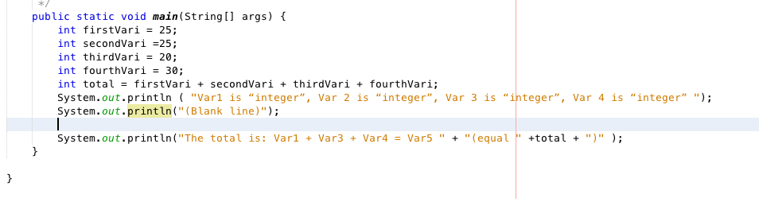



**2st  Task–**

Page 39. **in *Programming A Comprehensive Introduction***

**#13.** The moon’s gravity is about 17 percent that of the earth’s. (Meaning you weigh less on the moon). Write a program that computes your affective weight on the moon.

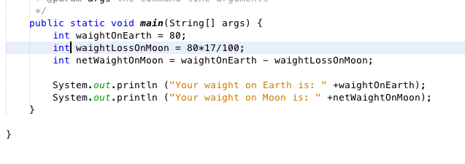

Macintosh HD:Users:ramyadav:Desktop:Screen Shot 2016-02-04 at 10.19.13 AM.png

Once you have completed your Program attach a picture of your program to this assignment and submit using your flash drive during lab-time.